Prompt Sensitivity and Silent Action Drift in OpenVLA
A Two-Stage Study on BridgeData V2

Final long research-paper draft and source package
Model: OpenVLA-7B (4-bit local inference)
Experiments: Manual40 + Auto50
Images evaluated: 180 total
Main variables: prompt family and state (initial vs final)
Prepared as a long-form submission draft for professor review and conference packaging
Important note: this is the long version. It is designed to be readable, detailed, and easy to defend.
The same content can later be compressed into an official conference template.

Abstract
Vision-language-action (VLA) models promise a simple interface for robot control: the model sees an image, reads a language instruction, and predicts the next robot action. Recent work suggests that current VLA systems do not always use language as reliably as their task success numbers imply. This paper studies that problem in OpenVLA-7B with a fully reproducible local evaluation pipeline. We run two complementary experiments on BridgeData V2 images. Manual40 contains 40 hand-selected trajectories with manually written task prompts. Auto50 contains 50 automatically sampled trajectories with prompts derived from run-family metadata. For every image we evaluate four prompt families: normal, paraphrased, contradictory, and neutral. We compare the predicted actions using the first six action dimensions, measuring both L2 drift and cosine similarity relative to the normal prompt. Across both experiments, paraphrases preserve behavior best, while contradictory and neutral prompts induce larger drift. Final-state images are more fragile than initial-state images in both branches. The paper does not claim a full safety solution. Instead, it offers a careful empirical slice of prompt robustness, a working local pipeline, and a concrete argument for using action drift as a future inference-time safety signal.

1. Introduction
Large vision-language-action models promise a simple idea: show the robot a camera image, tell it what to do in words, and let it predict the next robot action. OpenVLA is one of the most visible open-source examples of this idea and has become attractive because it can be run, adapted, and inspected by researchers without needing a closed industrial stack \cite{kim2024openvla}. At the same time, recent work has started to question how much these models truly depend on language once the scene is visually informative. Benchmarks such as LIBERO-X show that robustness can drop sharply under structured perturbations \cite{wang2026liberox}. LangGap argues that current VLAs often ignore language entirely unless the benchmark forces language understanding by design \cite{hou2026langgap}. IGAR shows that even contradictory instructions may still produce visually plausible actions, a failure mode it calls linguistic blindness \cite{zhang2026igar}. LangForce explains part of this behavior as information collapse, where the instruction becomes too predictable from the image and therefore stops influencing the action strongly enough \cite{lian2026langforce}.
This paper studies that problem from a practical, reproducible perspective. Instead of building a new benchmark from scratch, we take an existing open model, OpenVLA-7B, and test its sensitivity to four prompt families on BridgeData V2 images \cite{walke2023bridgedata}. We run two complementary evaluation branches. The first branch, which we call Manual40, contains 40 hand-selected trajectories with task-specific language written manually from the scene. The second branch, Auto50, contains 50 automatically sampled trajectories from the scripted BridgeData split and uses language prompts derived from the run-family metadata. For each image we compare a normal instruction against a paraphrased version, a contradictory version, and a neutral version. We then measure action drift relative to the normal prompt using the first six action dimensions, and we compare initial and final states separately.
Our contribution is modest but concrete. First, we provide a local, fully reproducible OpenVLA evaluation pipeline that runs under WSL with 4-bit loading and a patch for the image-text attention-mask mismatch encountered during inference. Second, we report a two-stage prompt-sensitivity study over 180 image evaluations in total: 80 images from Manual40 and 100 images from Auto50. Third, we show a consistent pattern across both branches: paraphrases preserve behavior best, contradictory and neutral prompts induce larger drift, and final-state images are more fragile than initial-state images. We do not claim to solve language robustness in VLAs. Instead, we provide a careful empirical slice of the problem, a concrete engineering recipe for reproducing the study, and a clear agenda for the next step: turning action drift into an inference-time safety signal.

2. Related Work
OpenVLA is the core model family for this study because it is open, large enough to matter, and practical enough to run locally. The broader field is moving quickly. LeRobot shows how much open infrastructure for robot learning has matured. The VLA survey attached by the user shows that the field now spans architecture, training, applications, and safety concerns. Recent robustness papers form the exact background of this project. LIBERO-X questions whether current evaluation protocols are really measuring language grounding. LangGap argues that many VLAs ignore language unless the benchmark forces semantic diversity. IGAR studies contradictory instructions and proposes a train-free repair at inference time. LangForce explains one possible cause: information collapse, where the image already predicts the task so well that language stops changing the action enough. SAFE and FailSafe go one step further and look at failure detection and recovery. Q-DIG treats prompt generation itself as a red-teaming problem. This paper does not try to beat all of that work. Instead, it offers a very reproducible OpenVLA case study that sits between benchmark diagnosis and future runtime safety.

3. Research Questions
This paper studies four questions. First, does OpenVLA preserve its predicted action under meaning-preserving paraphrases? Second, how much larger is the drift under contradictory or underspecified prompts? Third, are final-state images more fragile than initial-state images? Fourth, does the main pattern survive when moving from a hand-curated subset to a broader automatically sampled subset?

4. Experimental Setup

extbf{Model and runtime.} All experiments use OpenVLA-7B in 4-bit mode on a local WSL environment backed by an NVIDIA RTX 2060 GPU. The base model is loaded through the Hugging Face OpenVLA checkpoint with trust-remote-code enabled. We use the standard processor and the model's built-in exttt{predict\_action} interface.
extbf{Inference patch.} During initial testing we hit a critical mismatch between the text attention mask and the image-augmented embedding sequence. The practical symptom was a runtime failure after the visual tokens were fused into the transformer input. The fix was to prepend a 256-token image attention mask before calling exttt{predict\_action}. This patch does not change the OpenVLA weights; it only repairs the alignment expected by the model's inference path. This engineering step matters because without it the study would not be reproducible on the target local hardware.
extbf{Data.} The first evaluation branch, Manual40, was built manually from 40 BridgeData V2 trajectories. For each trajectory we saved one initial frame and one final frame, resulting in 80 total images. We then wrote one task-specific natural-language command per trajectory and derived three additional prompt variants from it. The second branch, Auto50, was created automatically from the downloaded scripted BridgeData split. We sampled 50 trajectories, extracted one initial frame and one final frame for each, and generated task prompts from the recorded run-family metadata. This produced 100 total images. The combined study therefore covers 180 image evaluations.
extbf{Prompt families.} Each image is evaluated with four prompt types: (1) \emph{normal}, which states the intended task directly; (2) \emph{paraphrased}, which keeps the meaning but changes the wording; (3) \emph{contradictory}, which intentionally conflicts with the original task; and (4) \emph{neutral}, which removes task-specific information and asks only what action the robot should take. The central question is whether the action predicted by OpenVLA remains stable under meaning-preserving changes and how strongly it shifts under meaning-breaking or underspecified prompts.
extbf{Metrics.} We measure drift using only the first six action dimensions, excluding the final scalar that often collapsed to a near-binary value in some runs. For each non-normal prompt, we compute (a) the $L_2$ distance from the normal action and (b) the cosine similarity with the normal action. Lower $L_2$ means less drift; higher cosine means more directional agreement. We also compute simple robustness counts: exact-all-same cases, near-all-same cases with max drift below 0.01, the number of times the paraphrase is the closest prompt to the normal action, and the number of times contradictory or neutral prompts are the farthest.
extbf{Analysis outputs.} We summarize the means, 95\% bootstrap confidence intervals, and a ranked list of high-drift cases. We deliberately keep the study simple: no simulator rollouts, no success-rate labels, and no active safety intervention. This makes the present paper a diagnosis-first study rather than a complete safety system.

5. Results
Table 1 is the main quantitative summary. Lower L2 means less drift. Higher cosine means more directional agreement with the normal prompt. The most important pattern is simple: paraphrases are always the closest prompt family, and final states are always harder than initial states.
Experiment | Group | n | L2-P | L2-C | L2-N | Cos-P | Cos-C | Cos-N
manual40 | initial | 40 | 0.028 | 0.042 | 0.045 | 0.679 | 0.586 | 0.426
manual40 | final | 40 | 0.043 | 0.060 | 0.071 | 0.480 | 0.219 | -0.002
auto50 | initial | 50 | 0.056 | 0.070 | 0.073 | 0.484 | 0.269 | 0.171
auto50 | final | 50 | 0.081 | 0.094 | 0.082 | 0.387 | 0.157 | 0.220
Meaning of Table 1: the paper has two experiments and four state groups, and in every one of them the paraphrased prompt changes the action the least. That means OpenVLA is somewhat sensitive to wording, but it reacts more strongly when the wording breaks meaning or removes task information.
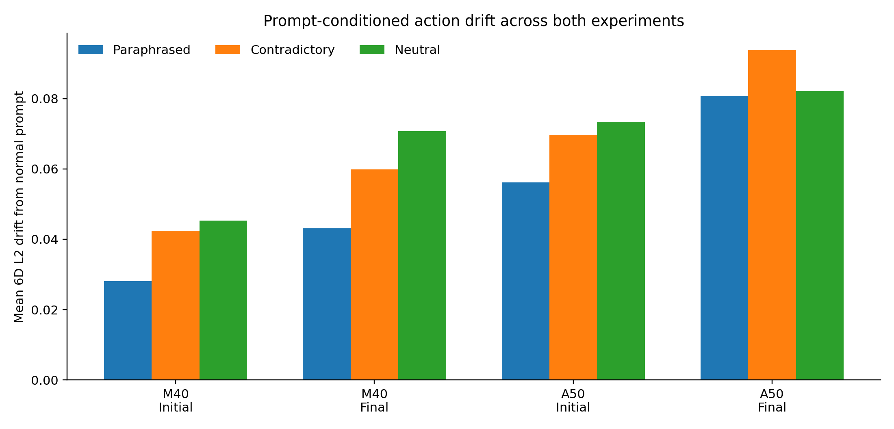
Figure 1. Mean L2 drift from the normal prompt. The bars show the same pattern visually: final scenes are more fragile than initial scenes, and paraphrases are the least disruptive prompt type.
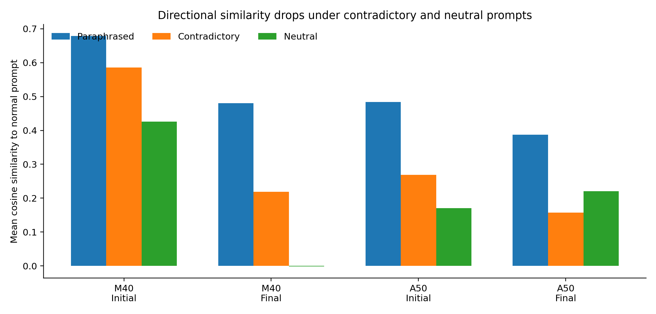
Figure 2. Mean cosine similarity to the normal prompt. This tells the same story as the L2 chart, but from the angle of action direction instead of magnitude.
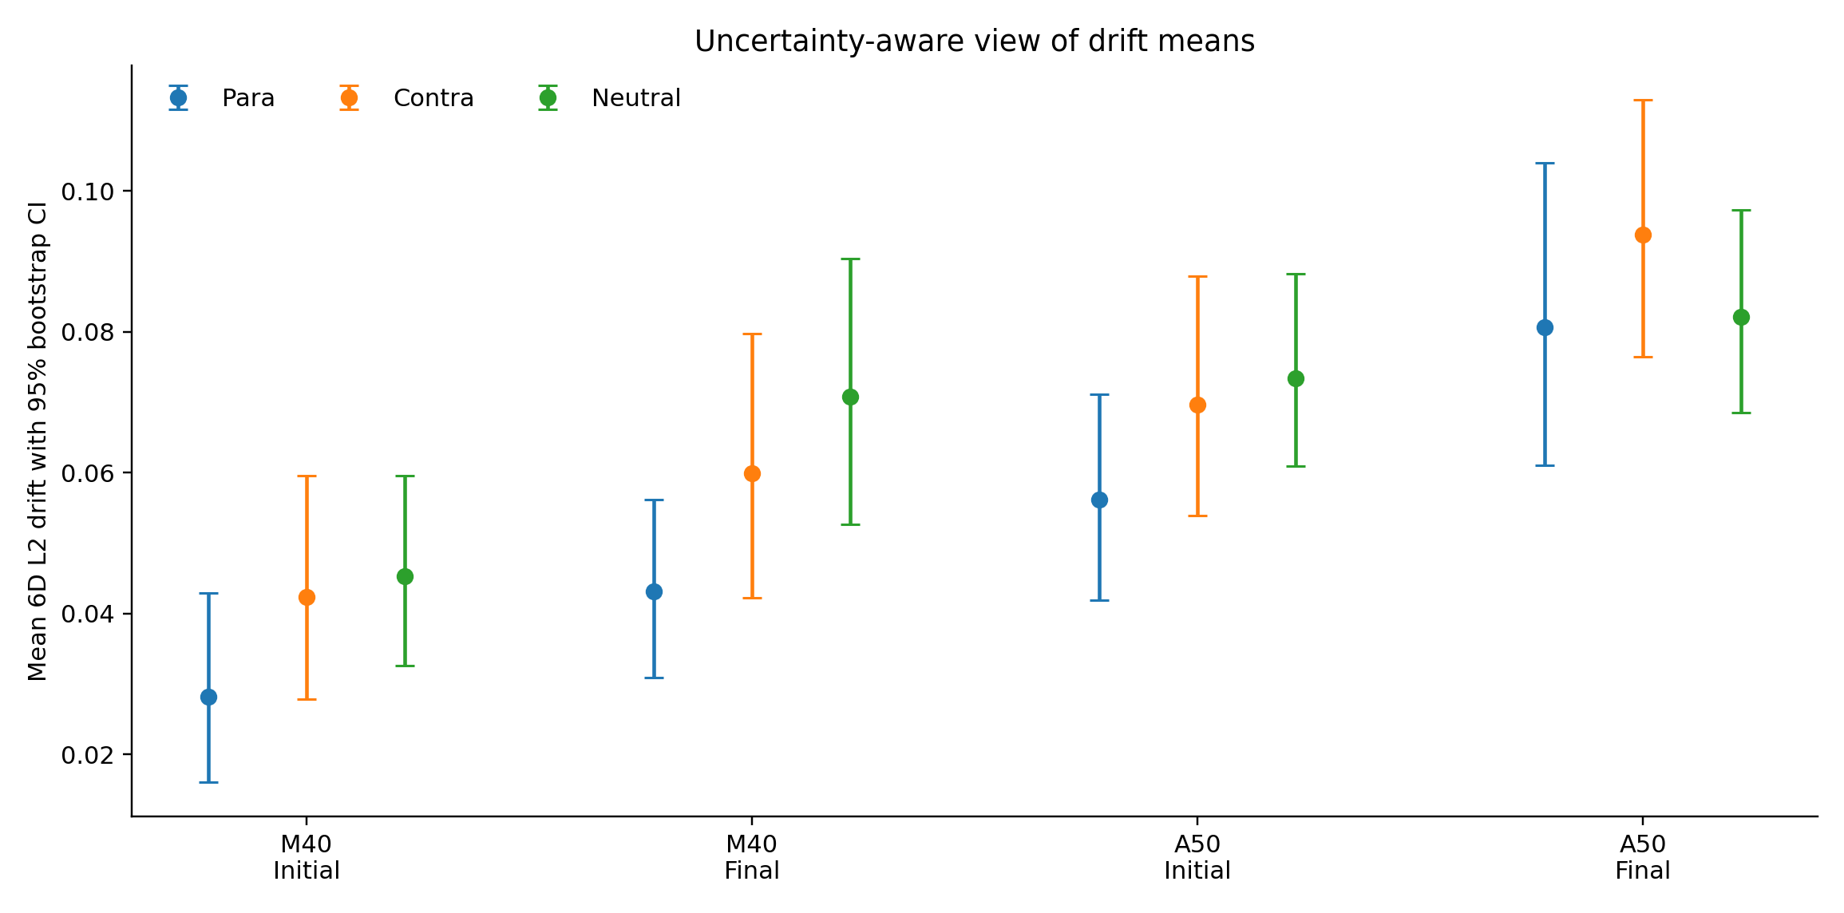
Figure 3. Bootstrap confidence intervals for L2 drift means. The uncertainty bands are not huge enough to erase the overall trend that paraphrases are safest and final states are harder.

5.1 Robustness counts
Manual40 counts
Group | Exact-all-same | Near-all-same | Paraphrase closest | Contradictory farthest | Neutral farthest
Manual40 Initial | 1 | 8 | 25 | 14 | 21
Manual40 Final | 0 | 4 | 22 | 12 | 21
Meaning of Manual40 counts: these counts show whether the model sometimes gives almost the same answer no matter what words are used. Manual40 still contains a few such cases, but Auto50 reduces them sharply, which suggests that language sensitivity is scene-dependent rather than completely absent.
Auto50 counts
Group | Exact-all-same | Near-all-same | Paraphrase closest | Contradictory farthest | Neutral farthest
Auto50 Initial | 0 | 1 | 27 | 15 | 22
Auto50 Final | 0 | 1 | 26 | 16 | 15
Meaning of Auto50 counts: these counts show whether the model sometimes gives almost the same answer no matter what words are used. Manual40 still contains a few such cases, but Auto50 reduces them sharply, which suggests that language sensitivity is scene-dependent rather than completely absent.

5.2 Representative high-drift cases
Experiment | Group | Image | Task | L2-P | L2-C | L2-N
auto50 | final | traj015_final.jpg | pick up the soft toy | 0.362 | 0.166 | 0.189
auto50 | final | traj004_final.jpg | pick up the object and place it in the bin | 0.297 | 0.253 | 0.100
manual40 | final | traj012_final.jpg | pick up the paper | 0.092 | 0.239 | 0.294
auto50 | initial | traj024_initial.jpg | pick up the object | 0.144 | 0.285 | 0.225
auto50 | final | traj049_final.jpg | pick up the utensil | 0.034 | 0.278 | 0.048
auto50 | initial | traj006_initial.jpg | pick up the object | 0.059 | 0.245 | 0.129
auto50 | initial | traj001_initial.jpg | pick up the rigid object | 0.105 | 0.241 | 0.181
manual40 | final | traj019_final.jpg | put the green object into the drawer | 0.068 | 0.240 | 0.073
Meaning of Table 4: the strongest failures are not random. They cluster in final scenes and in visually crowded pick-and-place tasks. That is useful because it tells us where a future safety detector should look first.

6. Discussion
The results are consistent enough to support three claims. First, paraphrases are the most stable prompt family in every group we studied. Second, contradictory and neutral prompts create materially larger drift than paraphrases, though the ordering between contradictory and neutral depends on the branch and state. Third, final-state images are more fragile than initial-state images in both Manual40 and Auto50.
In Manual40, the average 6D $L_2$ drift rises from 0.028 under paraphrases on initial frames to 0.043 on final frames. Contradictory drift rises from 0.042 to 0.060, and neutral drift rises from 0.045 to 0.071. This branch therefore shows a clean monotonic fragility pattern from initial to final states. The same story largely repeats in Auto50 but at a higher overall drift level. Auto50 initial-frame drift is 0.056 for paraphrases, 0.070 for contradictions, and 0.073 for neutral prompts. Auto50 final-frame drift increases further to 0.081 for paraphrases, 0.094 for contradictions, and 0.082 for neutral prompts. The final-state increase is therefore not confined to the manual branch; it survives the shift to a broader automatically sampled dataset.
The cosine results tell the same story from a directional rather than magnitude-based perspective. In Manual40 initial frames, paraphrase cosine remains high at 0.679, while contradictory and neutral drop to 0.586 and 0.426. In Manual40 final frames the drop becomes sharper, especially for contradictory and neutral prompts, with the neutral mean crossing slightly below zero. Auto50 cosine values are lower overall, again suggesting that the broader sampled branch is harder. Yet even there, paraphrases preserve the strongest alignment in both initial and final groups.
The invariance counts add an important nuance. In Manual40 we still observe one exact-all-same case and several near-all-same cases, especially on initial frames. Auto50 almost eliminates this effect, with only one near-all-same case in initial frames and one in final frames. This suggests that the manual subset contains some images where the task is visually overdetermined, but once the sampled branch becomes broader, OpenVLA is less likely to collapse to identical outputs across all prompts. In other words, the model is not uniformly blind to language; it is inconsistently sensitive, which may be even more dangerous in practice because the failure mode is scene-dependent rather than constant.
Finally, the top-failure ranking shows that the largest drifts concentrate in final scenes and in pick-and-place families involving soft toys, bins, and crowded object layouts. That pattern is intuitive. Final scenes often look more ambiguous because the goal may already be partly achieved, objects may be occluded, and the action space may contain both completion and correction motions. Under these conditions, a language change can more easily flip the model from a stable continuation policy to a qualitatively different adjustment policy. This observation points toward a useful next step: drift itself may be an early warning signal for prompt confusion.

7. Limitations and Future Work
This study has four important limitations. First, it evaluates action-space drift rather than true task success. We can show that the predicted action changes, but we cannot yet say how often that change would produce an execution failure, a recoverable deviation, or a harmless alternative trajectory. A simulator study or real-robot replay is needed for that step. Second, we evaluate one base model, OpenVLA-7B, rather than a cross-model panel. This makes the paper cleaner and more reproducible, but it limits claims about whether the same pattern holds across other VLAs such as $\pi_0$-FAST or OpenVLA-OFT. Third, the Manual40 and Auto50 branches are not identical in construction: one uses task-specific manual prompts, while the other derives language from run-family metadata. This is a strength for breadth but a limitation for strict apples-to-apples comparison. Fourth, we patched an inference-time attention-mask issue to make the model run locally. Although this does not alter the learned weights, any local engineering patch raises the question of whether hidden implementation details could affect robustness.
These limitations also explain why the problem is not already solved. Prompt robustness in VLAs is hard for at least three reasons. The first is data bias: in many robot datasets the scene already predicts the task strongly enough that the model can succeed by following visual shortcuts, a problem emphasized by LangForce and LangGap \cite{hou2026langgap,lian2026langforce}. The second is evaluation cost: measuring language sensitivity with real robots or large simulation suites is expensive, and fine-grained language perturbations multiply that cost quickly. The third is systems complexity: once a model mixes images, text, and low-level control, failures can originate from the data, the fusion architecture, the action head, or the runtime implementation itself.
Future work should therefore move in three directions. The first is \emph{outcome-aware evaluation}: run the highest-drift cases in simulation and test whether drift predicts task failure. The second is \emph{inference-time safety}: treat drift as a detector that can trigger re-prompting, abstention, or a safe retreat behavior, much like the failure-detection literature represented by SAFE and FailSafe \cite{gu2025safe,lin2025failsafe}. The third is \emph{stronger causal testing}: extend the study across multiple VLA families and across structured benchmarks such as LIBERO-X, which were designed to expose language and scene-understanding weaknesses more systematically \cite{wang2026liberox}.

8. Conclusion
We presented a fully reproducible prompt-sensitivity study for OpenVLA-7B using two BridgeData V2-based evaluation branches. Manual40 provides a hand-curated, task-specific view; Auto50 provides a broader sampled validation view. Across both branches, paraphrases preserve action behavior best, while contradictory and neutral prompts produce larger drift. Final-state images are consistently more fragile than initial-state images. The results do not prove that OpenVLA ignores language everywhere, but they do show that language sensitivity is uneven, scene-dependent, and weak enough to matter. That is already useful: a robot policy does not need to fail on every contradictory prompt to be unsafe. It only needs to fail unpredictably. Our study offers a concrete local pipeline, a set of reproducible results, and a practical basis for the next step: turning action drift into a real-time warning signal for safer VLA deployment.

References
[1] Kim et al., OpenVLA: An Open-Source Vision-Language-Action Model, 2024.
[2] Cadene et al., LeRobot: An Open-Source Library for End-to-End Robot Learning, 2026.
[3] Sapkota et al., Vision-Language-Action Models: Concepts, Progress, Applications and Challenges, 2026.
[4] Walke et al., BridgeData V2: A Dataset for Robot Learning at Scale, 2023.
[5] Liu et al., LIBERO: Benchmarking Knowledge Transfer for Lifelong Robot Learning, 2023.
[6] Wang et al., LIBERO-X: Robustness Litmus for Vision-Language-Action Models, 2026.
[7] Hou and Zhao, LangGap: Diagnosing and Closing the Language Gap in Vision-Language-Action Models, 2026.
[8] Zhang et al., Restoring Linguistic Grounding in VLA Models via Train-Free Attention Recalibration, 2026.
[9] Lian et al., LangForce: Bayesian Decomposition of Vision Language Action Models via Latent Action Queries, 2026.
[10] Gu et al., SAFE: Multitask Failure Detection for Vision-Language-Action Models, 2025.
[11] Lin et al., FailSafe: Reasoning and Recovery from Failures in Vision-Language-Action Models, 2025.
[12] Srikanth et al., Red-Teaming Vision-Language-Action Models via Quality Diversity Prompt Generation for Robust Robot Policies, 2026.

Appendix A. Exact numbers used in the paper
Manual40 initial drift: 0.028126 / 0.042365 / 0.04533
Manual40 final drift: 0.043141 / 0.05992 / 0.070772
Auto50 initial drift: 0.056164 / 0.069716 / 0.073405
Auto50 final drift: 0.080668 / 0.093857 / 0.082103
The ordering is stable enough to support the main qualitative claim: paraphrases preserve behavior best, while contradictory and neutral prompts produce larger action drift. The Auto50 final group is the only case where contradictory prompts exceed neutral prompts by a visible margin.

Appendix B. What is stopping this from being fully solved today?
First, the training data often lets the image predict the task too well, so the language channel is weak. Second, evaluation is expensive because each prompt variant multiplies the number of rollouts needed for trustworthy safety claims. Third, the full stack is complicated: data bias, model fusion, action decoding, and runtime engineering can all create or hide the problem. Fourth, even when a failure is detected, deciding what the robot should do next is not trivial; a safe fallback may reduce harm, but it may also reduce task completion if used too often. These are exactly the reasons why future work should focus on outcome-aware evaluation and inference-time safety mechanisms, not just more descriptive benchmarks.

